1. First, we install next auth

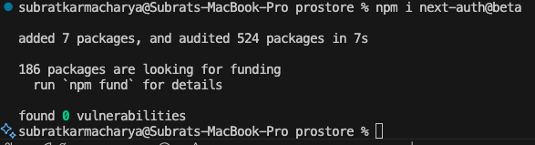

* Then we install the Prisma adapter

1. Then we set the required env variables

* We generate one using the below command



* Then save it to our env variables along with the URLS.

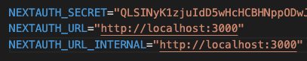

1. Now we made a new auth file in the root of our project and did the imports

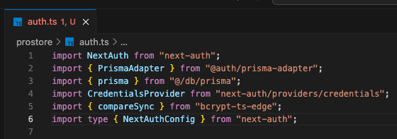

1. Created the config and then exported it

* We are basically setting the configuration as per the documentations.



1. Next js used the API for auth under the hood. But we need to configure it so that It can take over. So, we create this structure

* To test it, we can log something in here



* And we got the log

1. As we have separate auth ts file, we can simply add 2 lines and we will be fine

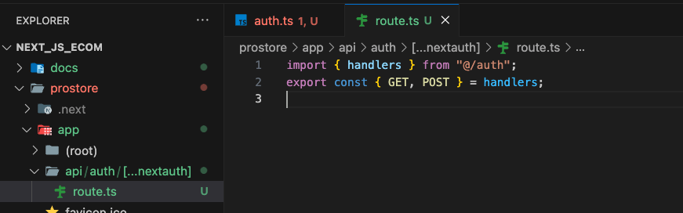

The handler we created in the auth will now work and show the session if it exists

